***Online Food Delivery System***

***Team:***

***Rohini Padhye***

***Nikita Shrivastava***

------------------------------------------------------------------------------------------------------------

***SRS Document:***

***Purpose of Project:***

This document contains the complete software requirements for Online Food Delivery System and describe the architectural designs needed to implement the system.

This system allows restaurant owners to quickly increase their business, by allowing customers to place order online and get it delivered to their place within minutes. It saves hassle of waiting time for consumers and crowd managing at restaurant owner side.

The system also allows to quickly and easily manage an online menu which customers can browse and use to place orders with just few clicks. Restaurant employees then use these orders through an easy way to navigate graphical interface for efficient processing.

***Scope of project:***

The system allows the admin to add or remove the daily menu, update feedback system, update delivery person’s details (add or remove a delivery person’s contact details) update discounts, new product launch. Consumer gets to select the menu, items from various categories, add the items, delete the items and payment facilities.

***Definition:***

**SOP**-Online Food Delivery System

**SRS**-Software Requirement Specification.

**GUI**-Graphical User Interface.

**Stack Holder**-The person who will participate in the system (Admin, Customer,Payment Gateway).

***Overview:***

This system provides an easy solution for students as well as faculty to communicate with each other in such a pandemic condition. Student can easily get his requirements (like notes, assignments, daily schedules, placement records, etc) on the given portal. Even it will be easier for the faculty to share the student requirements on the same platform in minutes.

This proposed system can be used by students studying in school, colleges, etc and system doesn't require any experienced user in computer field but the user must have basic knowledge of using or handling the computer.

***Functional Requirement:***

Requirements for having a successful Online Food Delivery:

*Registration:*

Registration is required for both Admin and Customer. Both needs to register under their specific category to further access page and perform desired activity.

*Login:*

Once the Registration is done, Admin and Customer can login using Login option by giving their emailed and password given at time of registration.

*Logout:*

Once the page is accessed by any of be it Admin or Customer, they may logout using Logout option provided on page.

*Payment Gateway:*

A secure payment gateway is provided for customers so that they experience a smooth and hassle-free transactions and also it reaches to owner/Admin.

***Non-Functional Requirement:***

* Smooth access for User.
* Accessibility
* Security
* Portability

***List of features:***

* Food Menu Management
* Account management.
* Customer management.
* Staff management.
* Discounts offered
* Monthly Revenue Reports.

***ER listing:***

* *Admin:*
* Employee ID
* First Name
* Last Name
* Age
* Contact Number
* Email Address
* Address
* Date of Birth
* Experience
* *Customer:*
* Customer ID
* First Name
* Last Name
* Age
* Date of Birth
* Address
* Email Address
* Frequent Customer or not
* Type of taste of Customer
* *Payment Gateway:*
* Card Details

***Tables:-***

* ***tblmenu***
  + menu_id
  + menu_name
  + price
  + menu_type_id
  + menu_image
  + menu_status
* ***tblmenutype***
  + menu_type_id
  + type_name
  + description
* ***tblcustomer***
  + customer_id – primary key of the table. It is set usually to auto_increment (the database will automatically give this column a value starting from 1).
  + customer_first_name
  + customer_last_name
  + customer_email
  + customer_phone_number
  + customer_username
  + customer_password
* ***tbluser***
  + user_id
  + full_name
  + contact
  + email_address
  + username
  + password
* ***tblorder***
  + order_id
  + customer_id
  + order_date
  + total_amount
  + order_status
  + processed_by
* ***tblorderdetails***
  + order_details_id
  + order_id
  + menu_id
  + amount
  + no_of_serving
  + total_amount
* ***tblpayment***
  + payment_id
  + order_id
  + amount –
  + paid_by
  + payment_date
  + processed_by

***Table Structure:-***

* ***User Table:***

|  |  |  |  |  |  |
| --- | --- | --- | --- | --- | --- |
| **Field** | **Type** | **Null** | **Key** | **Default** | **Extra** |
| Id | bigInt | NO | PRI | NULL | Auto_increment |
| full_Name | varchar(255) | NO |  | NULL |  |
| email | varchar(255) | NO | UNI | NULL |  |
| password | varchar(255) | NO |  | NULL |  |
| address | varchar(255) | NO |  | NULL |  |
| role_id | bigInt | NO | MUL | NULL |  |

* ***Roles Table:-***

|  |  |  |  |  |  |
| --- | --- | --- | --- | --- | --- |
| **Field** | **Type** | **Null** | **Key** | **Default** | **Extra** |
| Id | bigInt | NO | PRI | NULL | Auto_increment |
| Name | varchar(255) | NO |  | NULL |  |

* ***Category Table:-***

|  |  |  |  |  |  |
| --- | --- | --- | --- | --- | --- |
| **Field** | **Type** | **Null** | **Key** | **Default** | **Extra** |
| cat_id | bigInt | NO | PRI | NULL | Auto_increment |
| cat_name | varchar(255) | NO |  | NULL |  |

* ***Product Table:-***

|  |  |  |  |  |  |
| --- | --- | --- | --- | --- | --- |
| **Field** | **Type** | **Null** | **Key** | **Default** | **Extra** |
| menu_id | bigInt | NO | PRI | NULL | Auto_increment |
| menu_name | varchar(255) | NO |  | NULL |  |
| img_url | varchar(255) | NO | UNI | NULL |  |
| price | double | NO |  | NULL |  |
| cat_id | bigInt | No | MUL |  |  |

* ***Order Table:-***

|  |  |  |  |  |  |
| --- | --- | --- | --- | --- | --- |
| **Field** | **Type** | **Null** | **Key** | **Default** | **Extra** |
| orders_id | bigInt | NO | PRI | NULL | Auto_increment |
| date_created | datetime(6) | NO |  | NULL |  |
| order_tracking_  number | varchar(255) | NO | UNI | NULL |  |
| total_price | double | NO |  | NULL |  |
| total_quantity | int | NO |  | NULL |  |
| user_id | bigint | NO | MUL |  |  |

***Application Architecture:***

Application = Logic + data

Logic =(UI Logic + Business Logic + DataAccess Logic)

***Online Application:***

* *Web based Application:*

Deployed on web and accessed by users from anywhere.

***Logic:***

* *UI Logic:*

Web Pages + HTML controls + Web Components (React)

* *Navigation:*

(UI Routing) HTML Links, Routing mechanism

* *Data Binding:*

DOM

* *Event Binding:*

Action handler.

* *HTTP Request:*
  + GET:doget.
  + POST:dopost.
  + PUT:doput
  + DELETE:dodelete
* *Client-Side UI:*
  + HTML, CSS, JavaScript, bootstrap
  + UI (Client side UI Framework)
* *Web Logic:* (Server side processing)
* *Server UI:*
  + Model, View, Controller
  + Router
  + (SOA layer)
  + Spring Boot API
  + CRUD REST API
  + ORM Technique: Hibernate (ORM)
  + JPA
  + JDBC (database Connectivity)
  + State management
  + Client-side state management
  + cookies, query string, form collection, hidden variables local storage, session storage, Web SQL, Server side state management session, Cache, database
* *Business Logic:*

Java console application will be used to test business Logic

***Implementation:***

***Hardware/Software:***

This section informs hardware and software requirements needed to run the system efficiently.

***Hardware Requirements:***

* + 60 MB of free hard-drive space
  + 128 MB of RAM

***Software Requirements:***

* + *Operating System:* 
    - Windows (8 or above)
  + *Web Browser:* 
    - IE 10 or above, Mozilla Firefox or Google Chrome
  + *Drivers:* 
    - Java Runtime Environment
  + *Integrated Development Environment:* 
    - Eclipse J2EE , Apache Tomcat

***Diagram:***

***Use Case Diagram:***

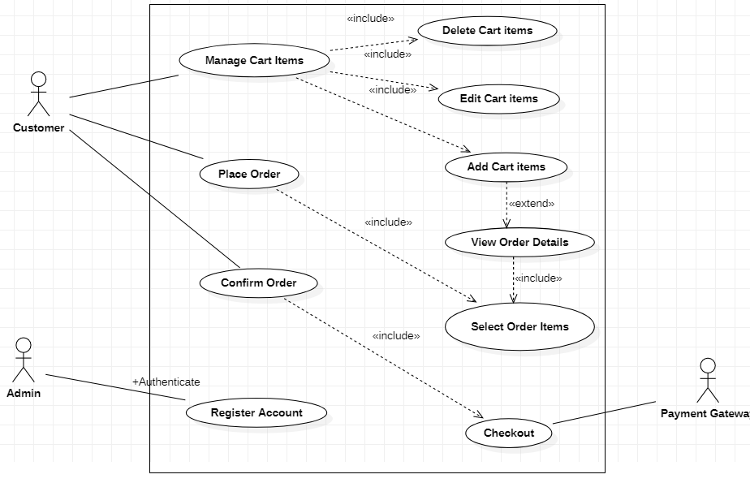

***E-R Diagram:***

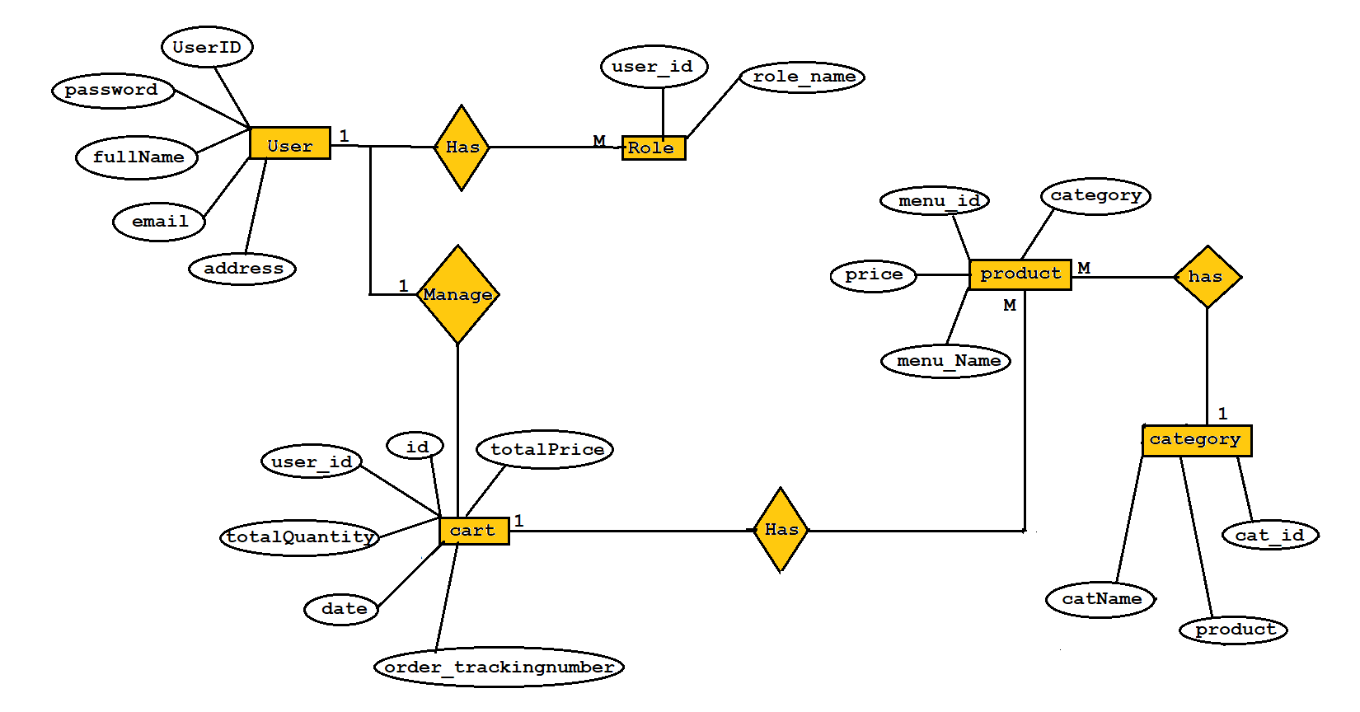

***Data Flow Diagram:***

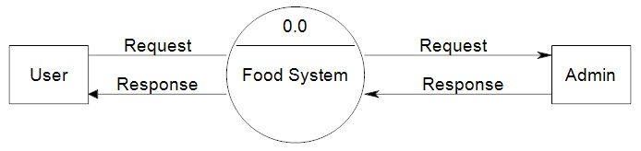

**Level 0**

*User Level DFD:*

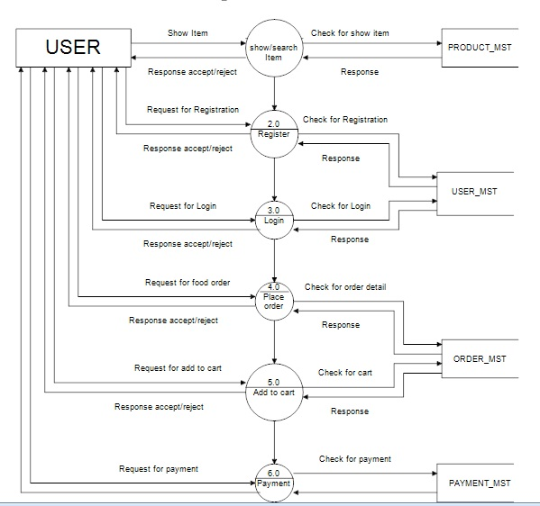

*Admin Level DFD:*

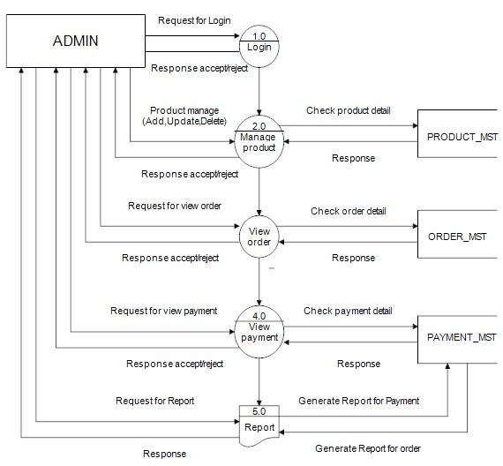

***Class Diagram:***

